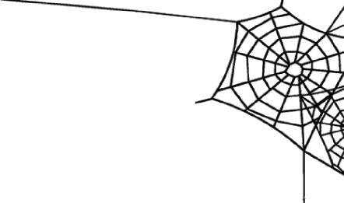

Historic Irvington Halloween Festival

Canine Costume Contest Registration Form

CONTESTANT No.___________ (assigned by Festival Volunteers)

First Name: _______________________ Last Name:___________________________________

Pet Name: ______________________________________________________________________

Street Address:

E-Mail: Phone:

**Judging Group: ____ (Adult + Dog) ____ (Child + Dog)**

Brief description of costume:_________________________________________________________

By signing this registration form, you are giving permission to the Historic Irvington Community Council & the Historic Irvington Halloween Festival to use a photograph of you, your child, and/or your pet for promotional use. If you are under 18 years of age, a parent or guardian must sign this form. If a parent or guardian is not present, you may enter the contest but a photo will not be taken. Prizes are awarded at the conclusion of the parade.

You (together with my parent or guardian if I am under the age of eighteen (18)) represent, covenant and agree on behalf of myself and my heirs, assigns, and any other person claiming by, under or through me, as follows: I acknowledge that participating in the Canine Costume Contest (“activity”) involves certain risks. I accept and voluntarily incur and assume all risks of any injury, damage, or harm that may arise during or result from my participation in the activity. I waive all claims against the Historic Irvington Halloween Festival and the Historic Irvington Community Council, Inc. for any injuries, damages, liabilities, losses or claims whether known or unknown which arise during or result from my participation in the activity. I agree to indemnify and hold harmless the Historic Irvington Halloween Festival and the Historic Irvington Community Council, Inc. for any injury or damage my pet causes or attempts to cause during and after the activity.

Signature (or Parent/Guardian if contestant under 18): _____________________________________________

B E L OW F O R J U D G E S U S E O N L Y

---------------------------------------------------------------------------------------------------------------------------------------------------

|  |  |
| --- | --- |
| Category | PLACEMENT  (CIRCLE ONE) |
| **Adult + Dog** | 1 2 3 |
| **Child + Dog** | 1 2 3 |